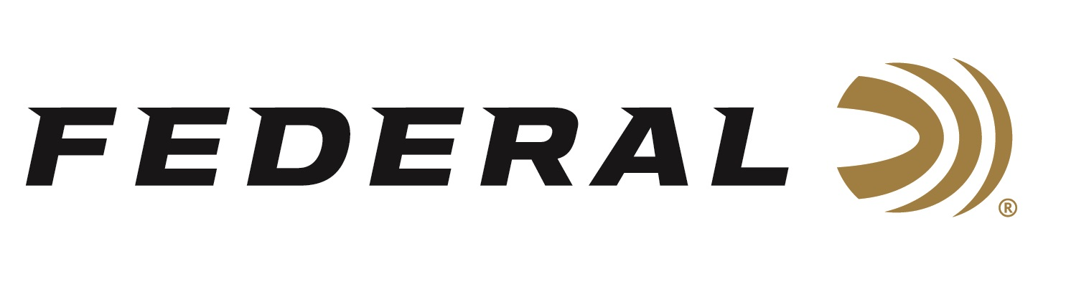

FOR IMMEDIATE RELEASE

**Federal Ammunition Sponsored Shooter Varick Beise Wins Multi-Gun Nationals Open Division**

**ANOKA, Minnesota –** **July 23, 2025 –** Federal Ammunition congratulates sponsored shooter Varick Beise on his USPSA Multi-Gun Nationals Open Division title held at the Forest Lake Sportsmens Club in Forest Lake, MN, July 18-20, 2025. The premier event, sponsored by Federal Ammunition, drew 117 of the best 3-gun shooters competing across twelve stages that require skill, speed, and precision.

Competing in his third USPSA Multi-Gun Nationals, the 19-year-old from Nickerson, Minnesota, bested a field of 54 competitors in the Open Division. During the event, Beise won five of the twelve stages against some of the top shooters in the sport, including fellow teammate Josh Froelich, who finished fourth in the Open Division.

“I started competing at the age of twelve,” said Beise. “Because I live in Minnesota and winter shortens our practice time outdoors, I spend a lot of time dry firing and mental preparation in the off season for these matches. I look forward to more opportunities to learn and mix it up with these and other amazing competitors as I see just how far we can go within the shooting sports.”

For his Open Division title, Beise utilized CCI’s Blazer Brass 124-grain 9mm for his handgun ammunition, Federal’s 69-grain Gold Medal Sierra Matchking for his .223 Rem. rifle ammunition and Federal’s 12-gauge Action Shotgun, designed specifically for the 3-gun competition shooter.

Federal Ammunition products are available at dealers nationwide and online. For more information on all Federal products and to sign up for notifications about new product availability, rebate promotions, and other brand news via email, visit [www.federalpremium.com](http://www.federalpremium.com).

**Press Release Contact:** JJ Reich  
Senior Manager – Press Relations  
E-mail: [media@tkghunt.com](mailto:media@tkghunt.com)

**About Federal Ammunition**

Federal, headquartered in Anoka, MN, is an ammunition brand of The Kinetic Group, owned by CSG, a globally diversified industrial group based in Prague, Czech Republic. Since 1922, Federal has been a leader in ammunition innovation, delivering high-quality sporting and hunting products to shooters worldwide. With a commitment to conservation and the outdoor community, Federal continues to manufacture industry-leading ammunition that enhances the shooting experience while supporting outdoor traditions.